DFD Figure 1.10.0.0.7 — Push Delivery Component

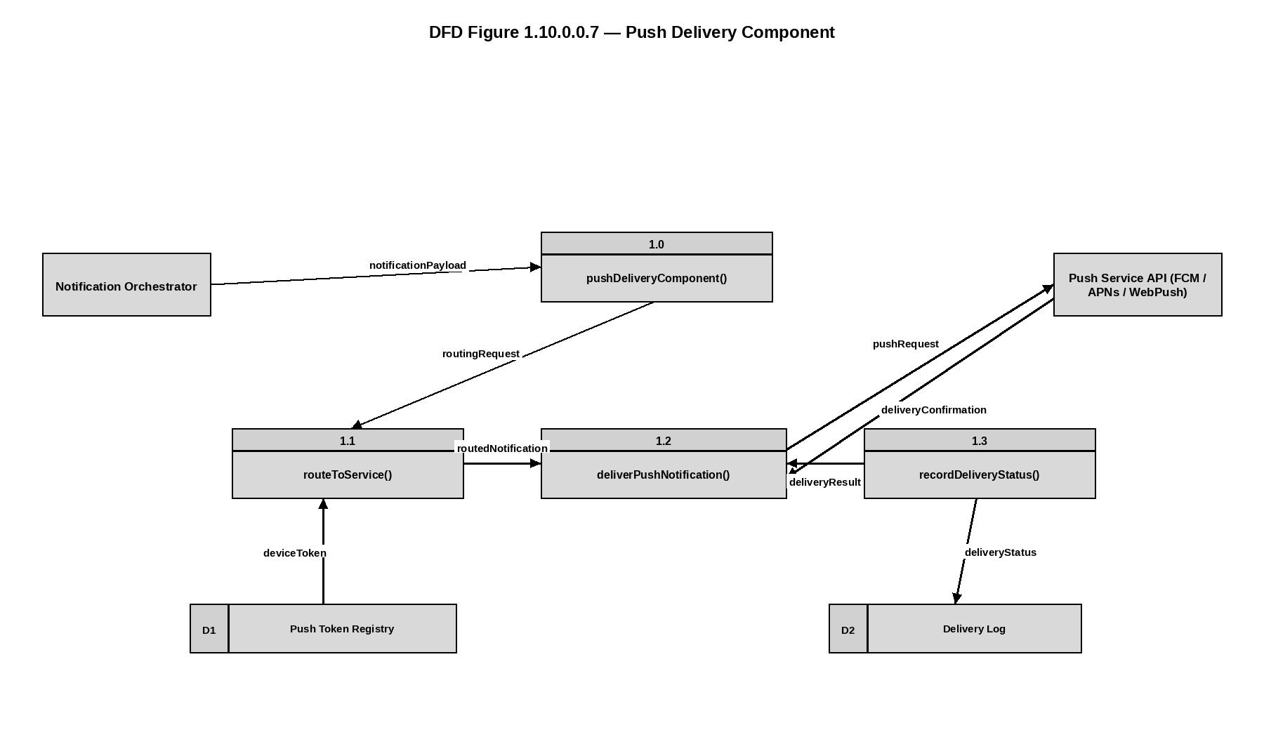
DFD Figure 1.10.0.0.8 — News Feed Manager
